TASK 1
A
- What is the minimum top-up amount?
- What is the maximum top-up amount per transaction?
- What is the maximum daily top-up limit?
- Is there a limit on the number of top-up transactions per day?
- Are decimal amounts allowed?
- How should the system handle empty, zero, negative, or invalid amounts?
- Is there any transaction/admin fee? If yes, does the fee count toward the limit?
- Do different payment methods have different minimum/maximum limits?
- Are there different fees for each payment method?
- What happens if a payment method is temporarily unavailable?
- For credit cards, are there additional validations such as CVV, expiry date, or 3D Secure/OTP?
- What should happen if the payment provider is slow, times out, or fails?
- What happens if the payment succeeds but the callback is delayed or fails?
- What happens if the user closes the browser after making the payment?
- Can the user start another top-up while the previous transaction is still pending?
- How do we prevent a user from being charged twice if they click Pay twice?
- Should the Pay button be disabled after the first click?
- What happens if the user refreshes the page or opens multiple tabs?
- Is there a maximum wallet balance?
- What transaction statuses should be displayed? For example: PENDING, SUCCESS, FAILED, CANCELLED, EXPIRED.
- What information should each transaction record contain?
- Should failed and pending transactions also appear in the history?
- When should a PENDING transaction change to SUCCESS or FAILED?
- What message should users see when a payment fails?
- What should users see when the provider times out?
- Is there a Retry button?
- If users retry, how do we prevent duplicate charges?
- Will users receive a notification when the payment succeeds or fails?
Top 3 Risks
Risk 1 — User is charged but wallet balance is not credited
The payment provider successfully deducts the user's money, but the wallet is not credited because of a callback failure, timeout, or internal system error.
Impact:
Users lose access to their money, support tickets increase, and the company may need to perform refunds or manual reconciliation.
Risk 2 — User is charged twice / wallet is credited twice
The user clicks Pay twice, refreshes the page, retries during a slow provider response, or the provider sends duplicate callbacks.
Impact:
The user may be charged twice or receive duplicate wallet credit, causing financial loss and reconciliation problems.
Risk 3 — Unclear payment status when the provider is slow or fails
The payment provider may be slow or unavailable, while the application does not clearly tell the user whether their money was deducted.
Impact:
Users may retry the payment unnecessarily, which can lead to duplicate charges and a significant increase in support tickets.
B
ID | Title | Precondition | Steps | Test Data | Expected Result | Priority
TC-01 | Successful top-up using Virtual Account | User is logged in and has access to Top-Up page | 1. Open Top-Up page.  2. Enter a valid amount.  3. Select Virtual Account.  4. Click Pay.  5. Complete payment successfully. | Amount: IDR 100,000 | Payment is successful, wallet balance increases by the correct amount, and a successful transaction record is created. | P1
TC-02 | Successful top-up using e-wallet | User is logged in | 1. Open Top-Up page.  2. Enter a valid amount.  3. Select e-wallet.  4. Click Pay.  5. Complete payment successfully. | Amount: IDR 100,000 | Wallet balance increases correctly and the transaction is recorded as successful. | P1
TC-03 | Successful top-up using credit card | User is logged in and has a valid card | 1. Open Top-Up page.  2. Enter a valid amount.  3. Select credit card.  4. Click Pay.  5. Complete any required card authentication. | Valid card, Amount: IDR 100,000 | Payment succeeds, wallet balance increases correctly, and one successful transaction is created. | P1
TC-04 | Minimum top-up boundary | User is logged in | 1. Open Top-Up page.  2. Enter the configured minimum amount.  3. Select a payment method.  4. Click Pay. | Minimum allowed amount | The minimum amount is accepted and payment can proceed successfully. | P1
TC-05 | Below minimum top-up is rejected | User is logged in | 1. Open Top-Up page.  2. Enter an amount below the minimum.  3. Select a payment method.  4. Click Pay. | Minimum - IDR 1 | Validation message is displayed and payment is not initiated. | P1
TC-06 | Maximum top-up boundary | User is logged in and has not reached the daily limit | 1. Enter the maximum allowed amount.  2. Select a payment method.  3. Click Pay.  4. Complete payment successfully. | Maximum allowed amount | Payment is accepted, wallet is credited correctly, and transaction is recorded. | P1
TC-07 | Amount above maximum/daily limit is rejected | User is logged in | 1. Enter an amount greater than the allowed limit.  2. Select a payment method.  3. Click Pay. | Maximum limit + IDR 1 | User receives a clear validation message and no payment request is initiated. | P1
TC-08 | Invalid amount validation | User is logged in | 1. Open Top-Up page.  2. Enter invalid values.  3. Try to proceed with payment. | Empty, 0, negative value, letters, special characters | Invalid amounts are rejected with an appropriate validation message and no payment is initiated. | P1
TC-09 | Payment provider failure | User is logged in and payment provider is available but configured to return failure | 1. Enter a valid amount.  2. Select a payment method.  3. Click Pay.  4. Simulate/trigger provider failure. | IDR 100,000 | Wallet balance does not increase. Transaction is recorded with the correct failure status and the user receives a clear error message. | P1
TC-10 | Payment provider timeout / unknown payment status | User is logged in and provider response is delayed | 1. Enter a valid amount.  2. Click Pay.  3. Simulate a timeout/delayed provider response.  4. Return to the application. | IDR 100,000 | User is clearly informed that payment status is pending/unknown. The wallet is not incorrectly credited, and the transaction status can be updated when the final provider result is received. | P1
TC-11 | Double-click Pay does not create duplicate charge | User is logged in and payment provider is available | 1. Enter a valid amount.  2. Select a payment method.  3. Click Pay twice quickly. | IDR 100,000 | Only one payment transaction is processed. User is charged once, wallet is credited once, and only one successful transaction is created. | P1
TC-12 | Retry after timeout does not cause double charge | First payment request is pending/has an unknown status | 1. Start a valid top-up.  2. Simulate provider timeout.  3. Retry the payment.  4. Make the original payment complete successfully as well. | IDR 100,000 | The same logical payment is not charged twice and the wallet is credited only once. Transaction records remain consistent with the final payment status. | P1
TC-13 | Duplicate provider callback does not duplicate wallet credit | A successful payment transaction exists and provider can send duplicate callbacks | 1. Complete a successful top-up.  2. Send/process the same success callback twice. | Transaction ID: same transaction | Wallet balance increases only once and the transaction remains a single successful transaction. | P1
TC-14 | Transaction history shows correct newest-first order | User has multiple completed transactions | 1. Complete multiple top-ups at different times.  2. Open /transactions. | Transactions at 3 different timestamps | Transactions are displayed newest first, with correct amount, payment method, status, and transaction details. | P2
TC-15* | Payment succeeds but user closes browser before redirect/callback | User has started a valid payment and payment provider can complete payment independently | 1. Start a top-up.  2. Complete payment at the provider.  3. Close the browser before returning to the application.  4. Reopen the application and check wallet/history. | IDR 100,000 | The payment result is eventually reflected correctly through the provider confirmation mechanism. Wallet is credited exactly once and the transaction status is correct. | P1
Generate QA test cases for the following Wallet Top-Up web application feature.
Users can add funds to their in-app wallet. The user opens the Top-Up page, enters an amount in IDR, selects a payment method (Virtual Account, e-wallet partner, or credit card), and clicks Pay. They are redirected to the payment provider. On successful payment, the wallet balance increases and a transaction record is created.
Additional requirements/notes:
- Minimum top-up should be reasonable but the exact value is not specified.
- Maximum per transaction is basically the daily limit.
- The system must never double-charge a user if they click Pay twice.
- The payment provider can sometimes be slow or fail.
- Users may not know whether their money was deducted when the provider is slow/fails.
- Transaction history is available at /transactions and shows newest first.
- There is no formal specification.
- Launch is next week.
Generate comprehensive test cases covering positive, negative, boundary, and edge cases. Include payment failures, timeout scenarios, duplicate payments, transaction history, wallet balance, and all payment methods.
Use this format:
ID | Title | Precondition | Steps | Test Data | Expected Result | Priority

C
TC | Problem | Why it is a problem | How to fix it
TC-01 | Expected result is too vague: “Top-up works correctly.” | It is not objectively verifiable. It does not specify what should happen to the balance or transaction status. | Specify measurable results, e.g. payment succeeds, transaction status becomes SUCCESS, and wallet balance increases by exactly the top-up amount.
TC-01 | No test data | The amount and payment method are unknown, so the test is not reproducible. | Add specific test data such as Rp50,000 and the selected payment method.
TC-02 | Rp5,000 is assumed to be below the minimum | There is no requirement provided stating what the minimum top-up amount is. This may be an AI hallucination. | Verify the actual requirement first. If the minimum is Rp10,000, test Rp9,999, Rp10,000, and Rp10,001.
TC-03 | Daily limit of Rp10,000,000 is assumed | The requirement does not state that the daily limit is Rp10,000,000. | Verify the documented limit before creating the test case.
TC-03 | Does not test cumulative daily top-ups | A daily limit normally needs to consider the total amount of multiple transactions, not only one transaction. | Test multiple transactions approaching and exceeding the daily limit.
TC-04 | “Valid amount” is not specific | The amount is not defined, so the test cannot be reproduced consistently. | Specify the exact amount and other required test data.
TC-04 | Only Virtual Account is tested | Other supported payment methods may be completely uncovered. | Identify all supported payment methods and test the critical ones.
TC-05 | “UI looks good and user friendly” is subjective | It is not measurable or directly testable as written. | Replace it with objective UI checks such as field validation, button state, error message visibility, loading state, and displayed balance.
TC-05 | High priority without justification | A general UI check is not automatically high priority. | Assign priority based on business impact and risk.
TC-06 | “Refreshing the page is allowed” is unclear | There is no requirement saying whether refresh during payment is allowed. | Separate the refresh scenario from the double-click scenario and verify the actual requirement.
TC-06 | Expected result says only “system shows an error” | A double-click does not necessarily need to produce an error. The important risk is duplicate charging/top-up. | Verify that only one transaction is created and the balance increases only once.
TC-06 | Timing is not clearly defined | Double-click behavior depends on when the second click occurs. | Define the steps precisely: enter amount → click Pay → immediately click Pay again.
TC-07 | Duplicate of TC-02 | Both test cases test a below-minimum amount. | Remove one and use the slot for another important scenario.
TC-07 | Rp10,000 is assumed to be invalid | If the minimum is actually Rp10,000, then Rp10,000 should be a valid boundary value. | If minimum is Rp10,000: Rp9,999 should be rejected, Rp10,000 accepted, and Rp10,001 accepted.
TC-08 | “Oldest first” is an unsupported assumption | No requirement says transaction history should be sorted oldest first. | Verify the actual sorting requirement before defining the expected result.
TC-08 | Expected result “pass” is meaningless | It does not describe what the tester should verify. | State the exact expected ordering and displayed transaction information.
TC-09 | Different-country scenario has no defined rule | There is no requirement saying top-ups from another country should be accepted or rejected. | Only test this if there is a documented country/geolocation restriction.
TC-09 | No expected result | It is impossible to determine what behavior is expected. | Define the expected behavior based on the requirement.
TC-10 | Rp1,000,000,000 is expected to succeed without evidence | This could exceed transaction, wallet, payment provider, or daily limits. | Do not assume it should succeed. Test the documented maximum boundary instead.
TC-10 | Large amount is not necessarily a boundary test | “Very large” does not mean it is the actual system boundary. | If the maximum is Rp5,000,000, test Rp4,999,999, Rp5,000,000, and Rp5,000,001.
All TCs | No preconditions | We do not know whether the user is logged in, has an active wallet, or has an available payment method. | Add relevant preconditions such as authenticated user, active wallet, and available payment method.
All TCs | No test data column | The cases are not sufficiently reproducible. | Add amount, payment method, user state, and other relevant data.
All TCs | Every case is High priority | This makes prioritization meaningless and does not reflect risk-based testing. | Use priorities based on business impact, likelihood, and launch risk.
All TCs | Insufficient negative and edge-case coverage | Most cases are happy-path or based on unsupported assumptions. | Add invalid input, boundaries, payment failure, timeout, duplicate submission, network interruption, etc.
All TCs | No payment failure scenario | A failed payment is an important negative case for a wallet feature. | Verify that a failed payment does not increase the wallet balance and that the transaction status is correct.
All TCs | No pending/timeout scenario | Payments may not complete immediately. | Verify correct behavior when payment remains pending or times out.
All TCs | Weak duplicate transaction coverage | Double-click is only one way duplicate transactions can happen. | Test repeated requests/retries and verify idempotency.
All TCs | No balance integrity validation | The most important business risk is an incorrect wallet balance. | Verify that new balance = old balance + successful top-up amount, and failed transactions do not increase the balance.
All TCs | No transaction history/status validation after top-up | The test set focuses mostly on balance and ignores transaction records. | Verify transaction status, amount, transaction ID, and history when those are part of the feature.
All TCs | No input validation coverage | There are no cases for empty, zero, negative, decimal, alphabetic, or invalid-format amounts. | Add relevant invalid-input and format tests based on the requirements.
All TCs | No concurrency/race-condition consideration | Multiple requests submitted close together can potentially cause duplicate balance updates. | Test multiple legitimate top-ups submitted close together and verify each is recorded exactly once.
All TCs | Assumptions are presented as requirements | This is the biggest quality problem with the AI-generated set. | Clearly distinguish documented requirements from assumptions. If a rule is unknown, raise a clarification question instead of inventing an expected result.

TASK 2
- ID: T001
Title: Cannot click button remove in homepage
Severity: Critical
Priority: P1
Environment: Firefox, Windows 10, problem user
Preconditions: Login as problem_user
Steps to Reproduce: Login, Click Add to Cart button, Click Remove button
Expected Result: The button will change back to Add to Cart and the item will be remove from the list
Actual Result: The remove button cannot be click
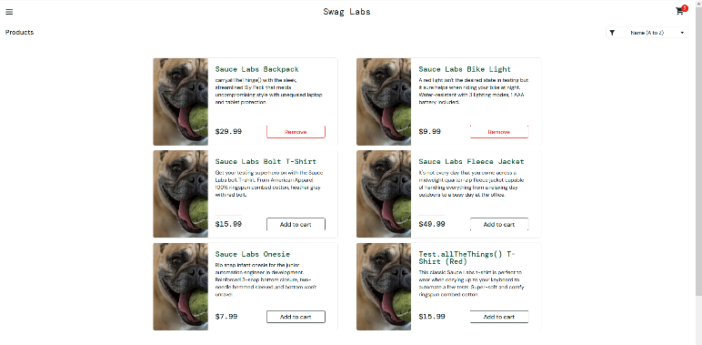
Evidence:

Notes: Must use problem user

- ID: T002
Title: Cannot insert Last Name in Checkout page
Severity: Critical
Priority: P1
Environment: Firefox, Windows 10, problem user
Preconditions: Login as problem_user & must have item in cart
Steps to Reproduce: Login, Click Cart, Click Checkout, Insert First Name, Last Name & Zip/Postal Code
Expected Result: Can insert First Name, Last Name & Zip/Postal Code
Actual Result: When typing in Last Name field the one get change are First Name field
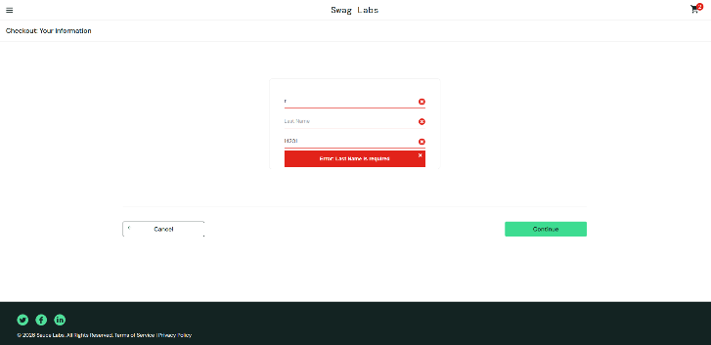
Evidence:

Notes: Must use problem user

TASK 3
A

B
- SELECT
RoomType,
SUM(AmountIDR) AS TotalAmountIDR
FROM Bookings
WHERE Status = 'COMPLETED'
AND CheckIn >= '2026-07-01'
AND CheckIn < '2026-08-01'
GROUP BY RoomType;

- SELECT
GuestName,
CheckIn,
COUNT(*) AS BookingCount
FROM Bookings
GROUP BY GuestName, CheckIn
HAVING COUNT(*) > 1;

- I will make a rule that CheckOut cannot be less than CheckIn
C
The validation happens on the client side. When using DevTools there are no login request sent to the server, only validation message appears in the browser

